**Library Management System**

The Library Management System using Django Rest Framework as Backend and React Js as Frontend.

* **Register**: The Admin has to register himself with the required fields.
* **Login**: After Registration the Admin can login to the system with his credentials.
* If Admin is already registered then he will be able to login Directly.
* Once Admin is login into the system
* He can Add, Update, Retrieve and Delete books.
* If Admin is not logged in, he will not have the access to perform these operations.
* Admin can also logout himself from the system.
* Students are able to see the books available in the library at the Home page.

**Installation Instructions:**

**After cloning the repository**

**For Database:**

* Start the Apache and mySQL server using Xampp Control Panel
* Go to <http://localhost:8080/phpmyadmin/> in your browser
* Create a database name as “*library”*
* Import sql file “*library.sql*” from root Directory of Project in “*DB”* folder

**For Backend:**

* Install the requirements:

*#> pip install -r requirements.txt*

* Start backend server by using command:

#> *python manage.py runserver 8000*

*Note: this is mandatory to start the server on the port :8000*

*And the address should be* [*https://127.0.0.1:8000*](https://127.0.0.1:8000)

**For Frontend:**

Use commands

* npm install
* npm start

*Note: this is mandatory to start the server on the port :3000*

*And in browser, insted of* [*http://localhost:3000*](http://localhost:3000) *you have to use* [*http://127.0.0.1:3000*](http://127.0.0.1:3000)

*Otherwise you will not be able to login in the system.*

**Project OverView**

1. Home Page :- <http://127.0.0.1:3000/>

In this Page The admin or the student can see the available books in the library.

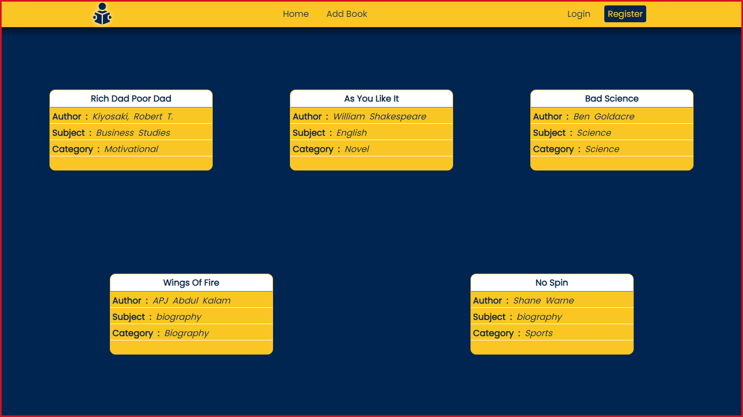

1. Register:- <http://127.0.0.1:3000/signup>

In this Page The admin can Register himself in the system.

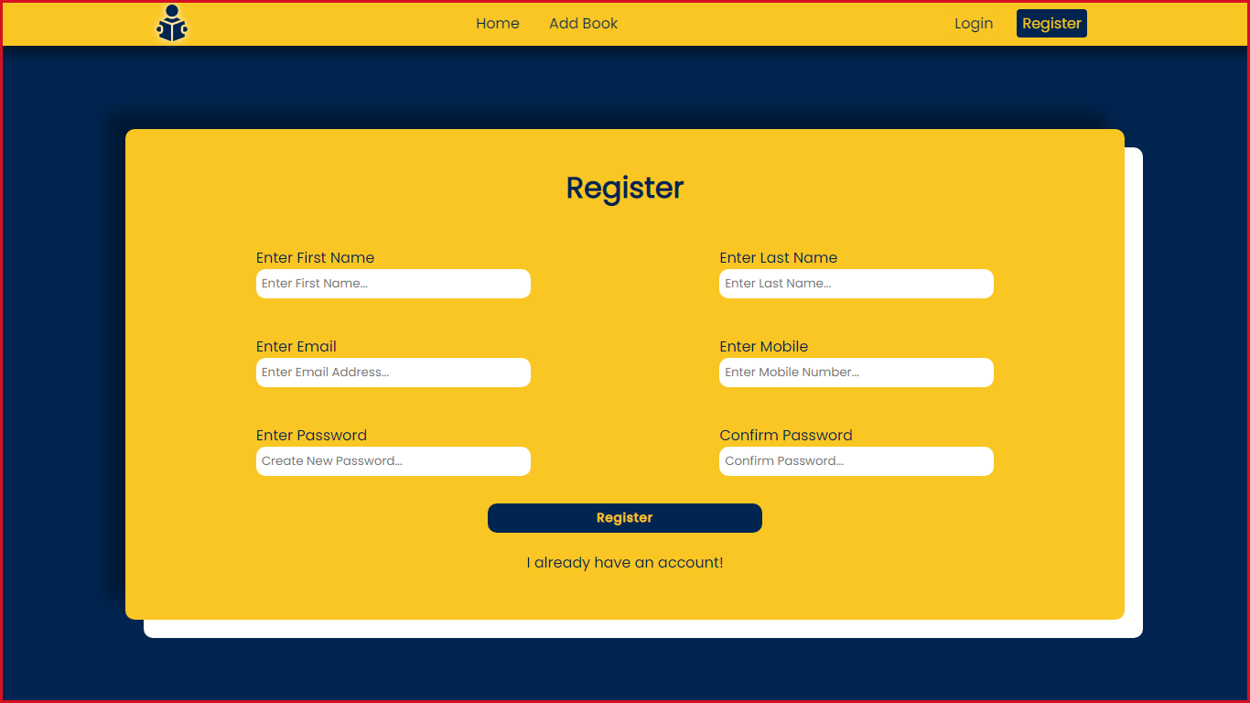

1. Login:- <http://127.0.0.1:3000/login>

In this Page The admin can Login himself after Registration.

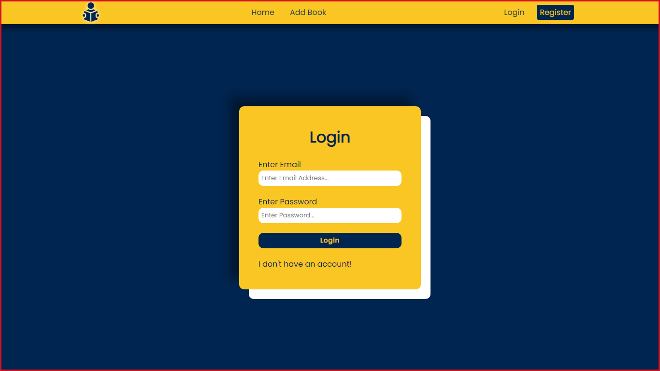

1. AddBook:- <http://127.0.0.1:3000/addbook>

In this Page The admin can add new book to the library.

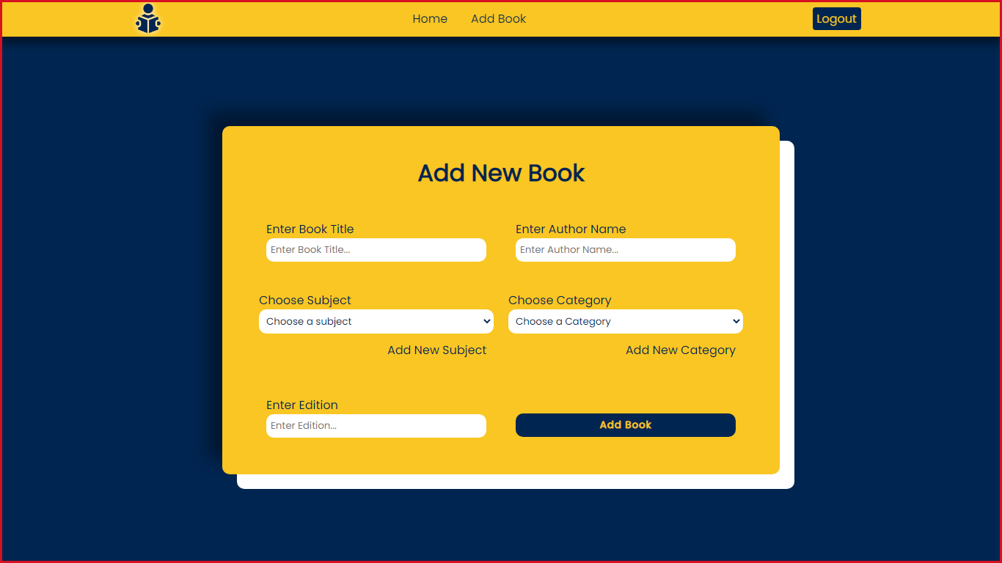

1. UpdateBook:- <http://127.0.0.1:3000/updatebook/1>

On Home Page When the admin Hover on any book he can update the existing book with the book id.

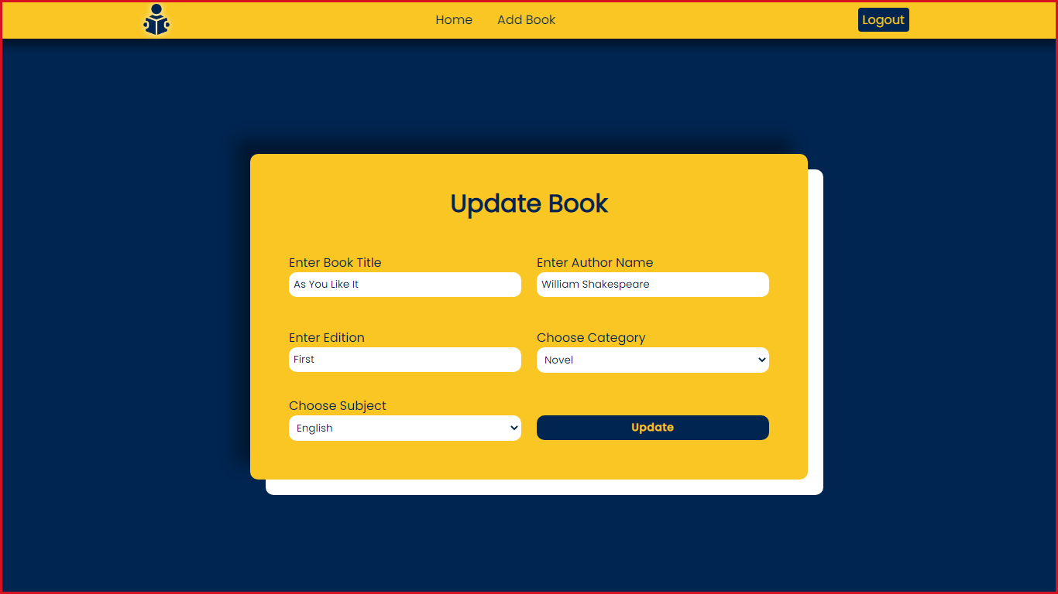

1. DeleteBook:- <http://127.0.0.1:3000/deletebook/1>

On Home Page When the admin Hover on any book he can delete the existing book with the book id.

